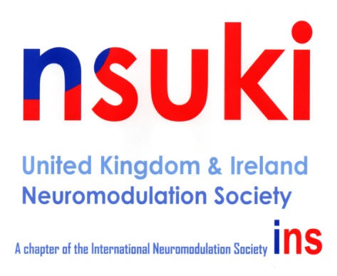
Neuromodulation Society UK and Ireland
Association of Anaesthetists of Great Britain & Ireland
21 Portland Place
London
W1B 1PY

Tel: 0207 631 8816
neuromodulation@aagbi.org

14 March 2023

Dear Member,

Nominations for the posts of Board Member x1
Nominations for the posts of Board Member (Neurosurgical Representative) x1
I am writing to seek nominations for the above posts. Self-nomination is permitted and the current Secretary / President would be willing to second suitable candidates known to them.

The closing date for receipt of nominations will be 10th April 2023 at 5pm. This will give us enough time to hold an election, if necessary, and have the new officers appointed.

Please make sure that your completed nomination form reaches the NSUKI Secretariat by this date.

All forms should be sent by mail or email to:
Craig Allum
The Neuromodulation Society UK & Ireland
21 Portland Place,
London
W1B 1PY
email: neuromodulation@anaesthetists.org

Yours sincerely,

Dr Ashish Gulve
President, NSUKI

Neuromodulation Society UK and Ireland
Association of Anaesthetists of Great Britain & Ireland
21 Portland Place
London
W1B 1PY

Tel: 0207 631 8816
neuromodulation@aagbi.org

Please select which post you are applying for
Board Member Board Member (Neurosurgical Representative)

I hereby propose (block capitals please):
NAME:
CURRENT APPOINTMENT:
ADDRESS:

TELEPHONE: Mobile Work
for nomination as board member / board member (Neurosurgical Representative)
Proposer: Signed:
Seconder: Signed:
Nominee, proposer and seconder MUST be members of NSUKI for no less than one year. Self-nomination is permitted and the Secretary / President would be willing to second suitable candidates known to them.
Please give a short description of your current post and interests in 50 words or less:

I hereby accept nomination to the NSUKI COUNCIL.
Signature of Nominee: Date:………………….
Please return this form no later than 10th April at 5pm to: Rebecca Batson, Neuromodulation Society, 21 Portland Place, London, WIB 1PY, United Kingdom.
Please email the NSUKI Secretariat neuromodulation@anaesthetists.org, by 10th April 2023 at 5pm to confirm your nomination.

